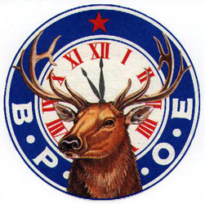
Elks#1139 Scholarship

$1000.00 One Year Scholarship
(Non-Renewable)

BASED ON SCHOLARSHIP, LEADERSHIP AND FINANCIAL NEED

To be considered for this scholarship the following conditions must be met:
- You must be a graduating senior in the current year of classes.
- Your parent, legal guardian, or grandparent must be a member in good standing of Greenville Elks Lodge #1139. Children of deceased members are also eligible.
- You must be planning to attend an accredited 2-4 year school.
- Application must be made on this form only, signed and dated by the Applicant.
- Official signed transcript of high school grades must be attached to application.
- CEEB, SAT and ACT scores must be attached to application.
- Copies of exhibits of achievements in scholarship, leadership, athletics, dramatics, community service, and/or other activities may be attached to application.
- Deadline for submission is March 15, 2022 .

Sponsoring Member’s Name
Applicant’s Name
Address

Phone #
Cell #
Father’s Name
Mother’s Name
School(s) Attended (9th-12th grades)
Date of Graduation
GPA Class Ranking
Community Service(s) Performed Year
Year
Year

EXTRA CURRICULAR (School Related)
Honors or Awards Year
Year
Year
Offices Held Year
Year
Year
Positions of Leadership Year
Year
Year
Memberships Held Year
Year
Year

CIVIC (Non-School Related)
Honors or Awards Year
Year
Year
Offices Held Year
Year
Year
Positions of Leadership Year
Year
Year
Memberships Held Year
Year
Year

EMPLOYMENT
Company Name
From To

Name of College to be attended
College Student ID # (if known)

